Topic 6 / Chapter 7

Database Management & CIS 1246

|  |  |
| --- | --- |
| Author: | Christopher Sigouin |
| Date: | March 18 |
| Date Due: | March 23 |
| Assignment: | Topic 6 |
|  | Task: 1 |
|  |  |
|  |  |
| Mark: ____________ | |

**Chapter 7 / Exercises #29 - #43**

**29. Using the output shown in Figure P7.29 as your guide, generate a list of customer purchases, including the subtotals for each of the invoice line numbers. (Hint: Modify the query format used to produce the list of customer purchases in Problem 28, delete the INV_DATE column, and add the derived attribute LINE_UNITS * LINE_PRICE to calculate the subtotals.)**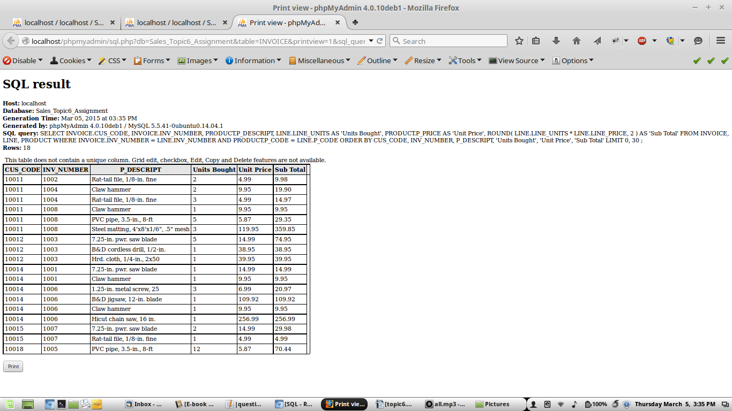

**30. Modify the query used in Problem 29 to produce the summary shown in Figure P7.30.**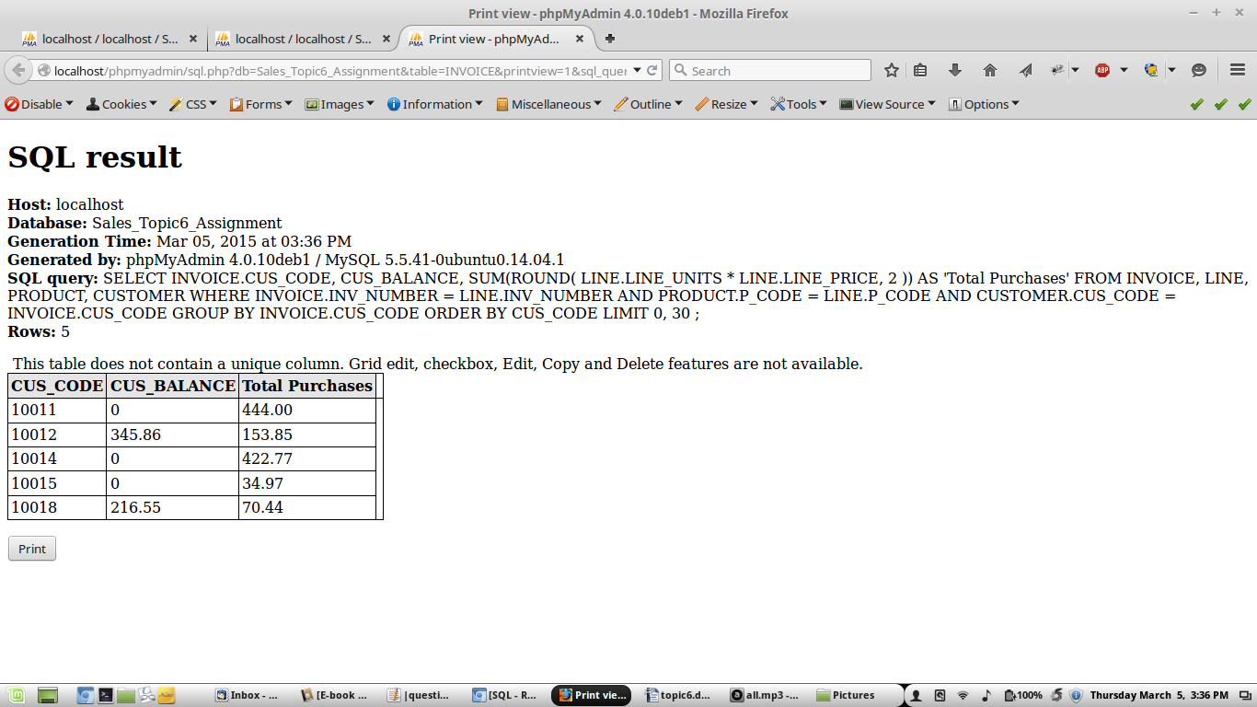

**31. Modify the query in Problem 30 to include the number of individual product purchases made by each customer. (In other words, if the customer’s invoice is based on three products, one per LINE_NUMBER, you count three product purchases. Note that in the original invoice data, customer 10011 generated three invoices, which contained a total of six lines, each representing a product purchase.) Your output values must match those shown in Figure P7.31.**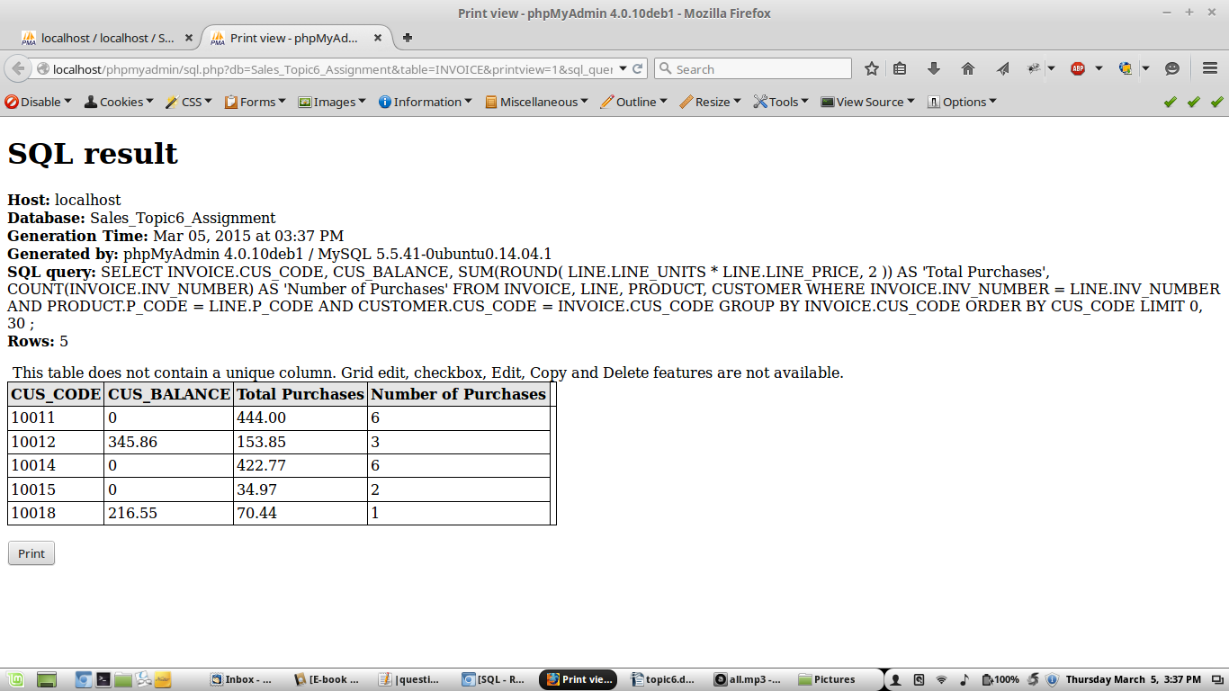

**32. Use a query to compute the average purchase amount per product made by each customer. (Hint: Use the results of Problem 31 as the basis for this query.) Your output values must match those shown in Figure P7.32. Note that the average purchase amount is equal to the total purchases divided by the number of purchases per customer.**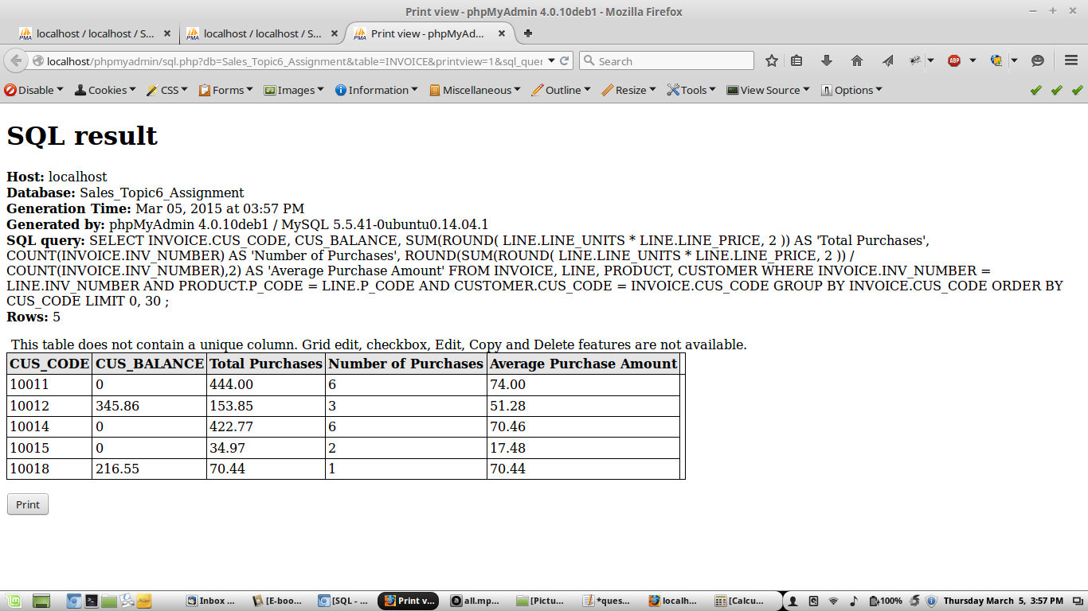

**33. Create a query to produce the total purchase per invoice, generating the results shown in Figure P7.33. The invoice total is the sum of the product purchases in the LINE that corresponds to the INVOICE.**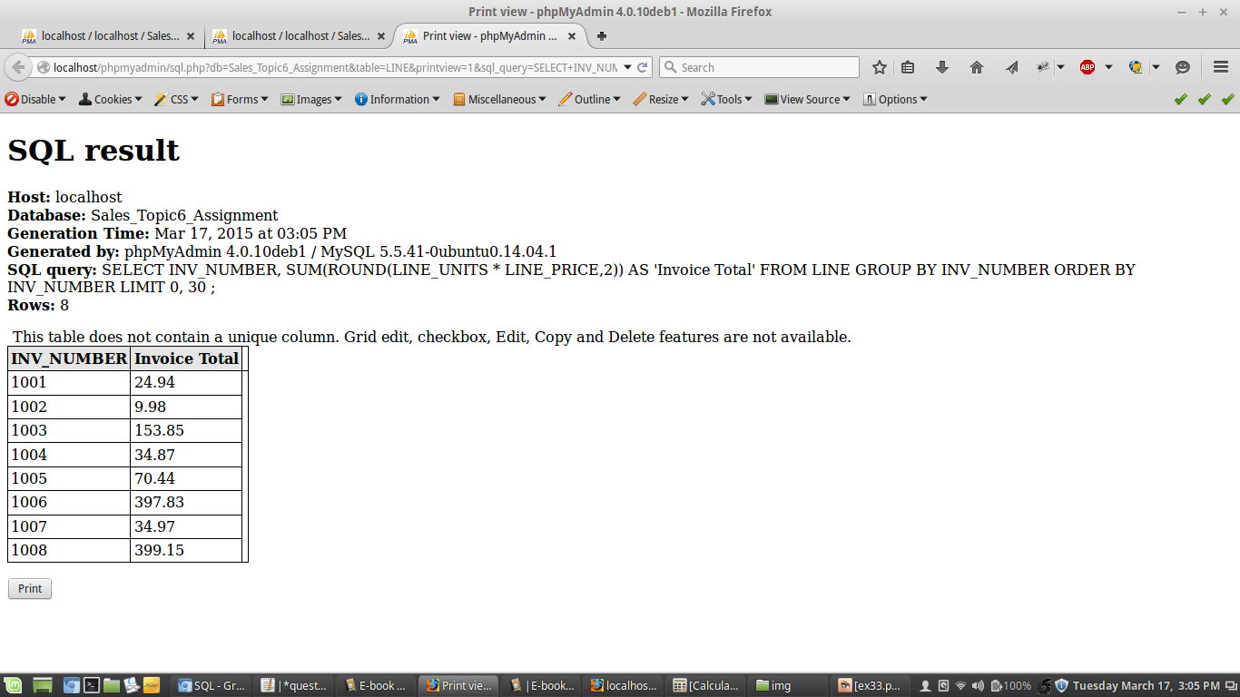

**34. Use a query to show the invoices and invoice totals in Figure P7.34. (Hint: Group by the CUS_CODE.)**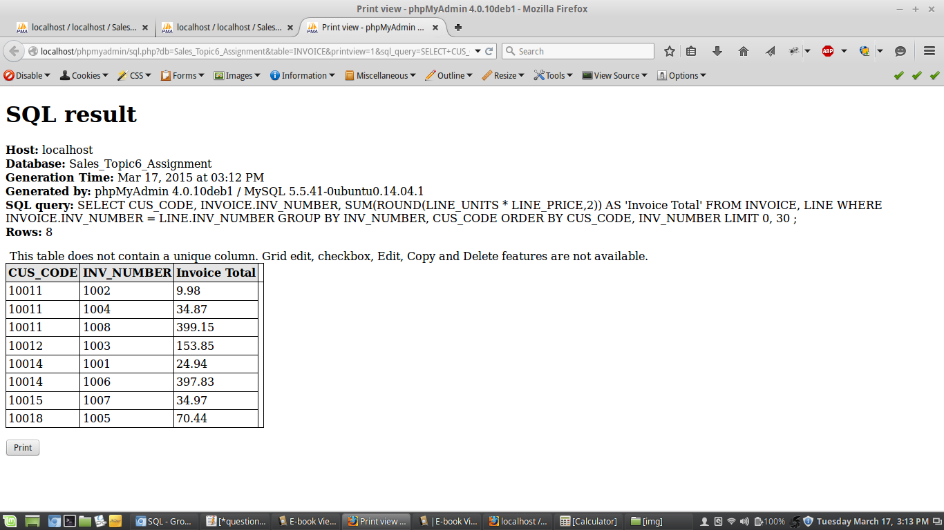

**35. Write a query to produce the number of invoices and the total purchase amounts by customer, using the output shown in Figure P7.35 as your guide. (Compare this summary to the results shown in Problem 34.)**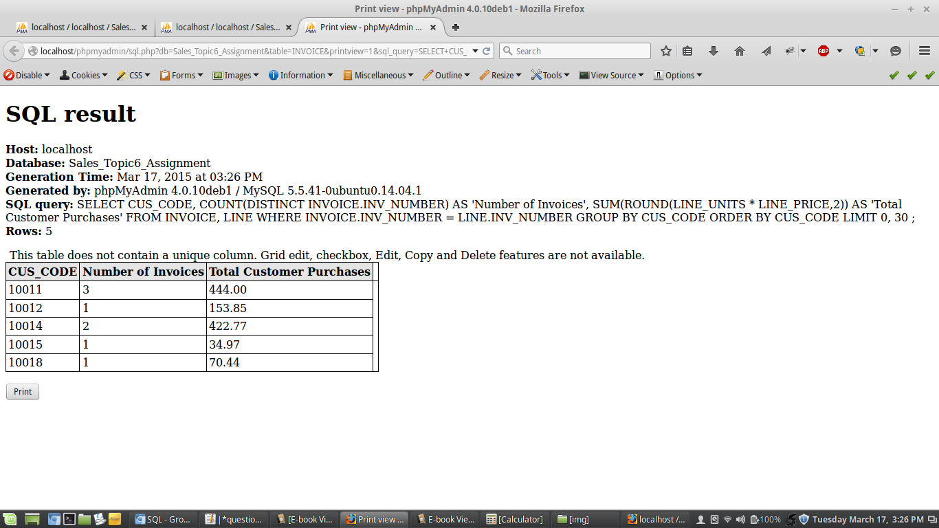

**36. Using the query results in Problem 35 as your basis, write a query to generate the total number of invoices, the invoice total for all of the invoices, the smallest invoice amount, the largest invoice amount, and the average of all the invoices. (Hint: Check the figure output in Problem 35.) Your output must match Figure P7.36.**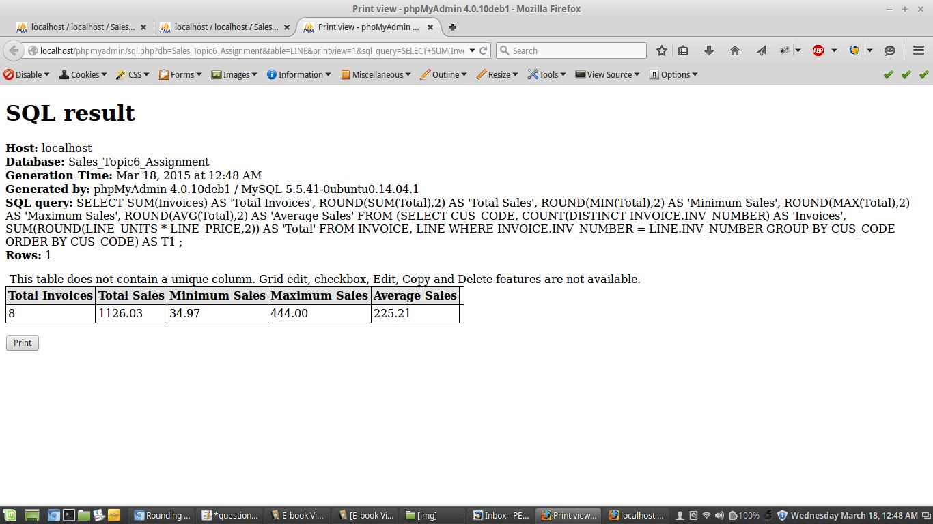

**37. List the balances of customers who have made purchases during the current invoice cycle—that is, for the customers who appear in the INVOICE table. The results of this query are shown in Figure P7.37.**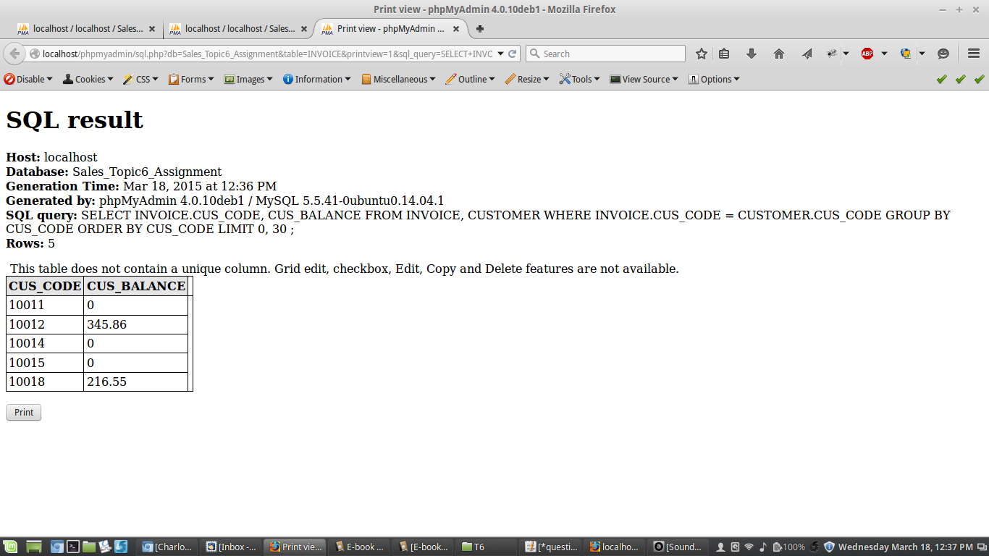

**38. Using the results of the query created in Problem 37, provide a summary of customer balance characteristics, as shown in Figure P7.38.**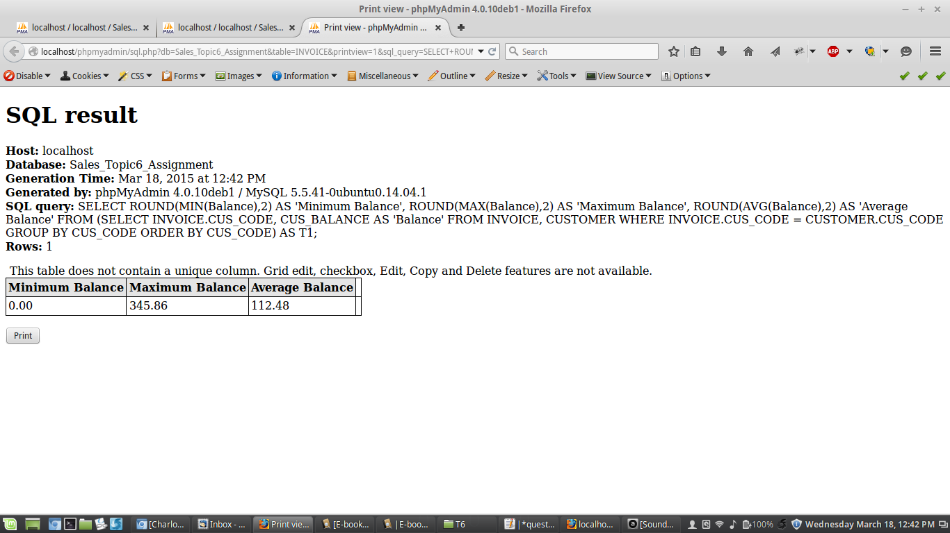

**39. Create a query to find the balance characteristics for all customers, including the total of the outstanding balances. The results of this query are shown in Figure P7.39.**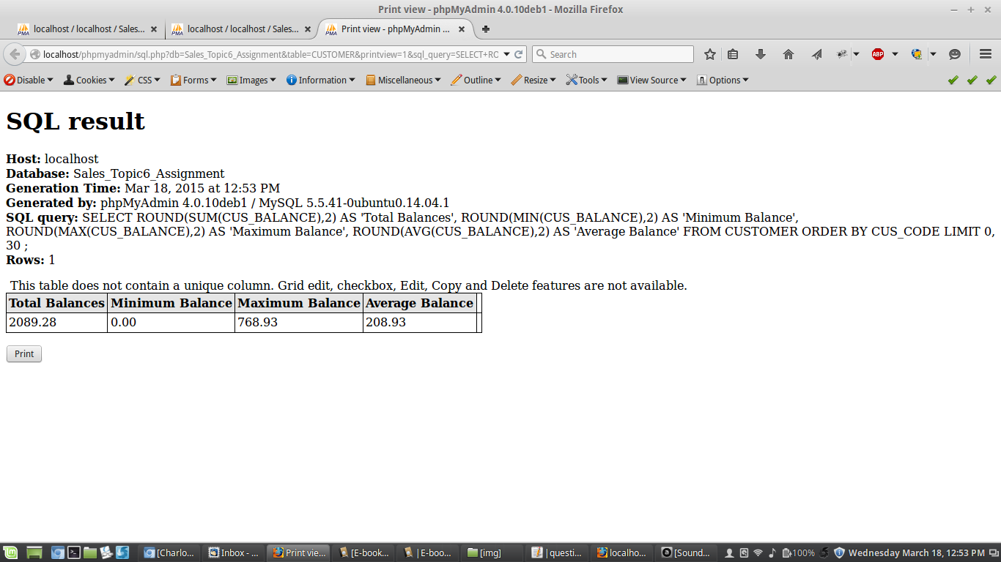

**40. Find the listing of customers who did not make purchases during the invoicing period. Your output must match the output shown in Figure P7.40.**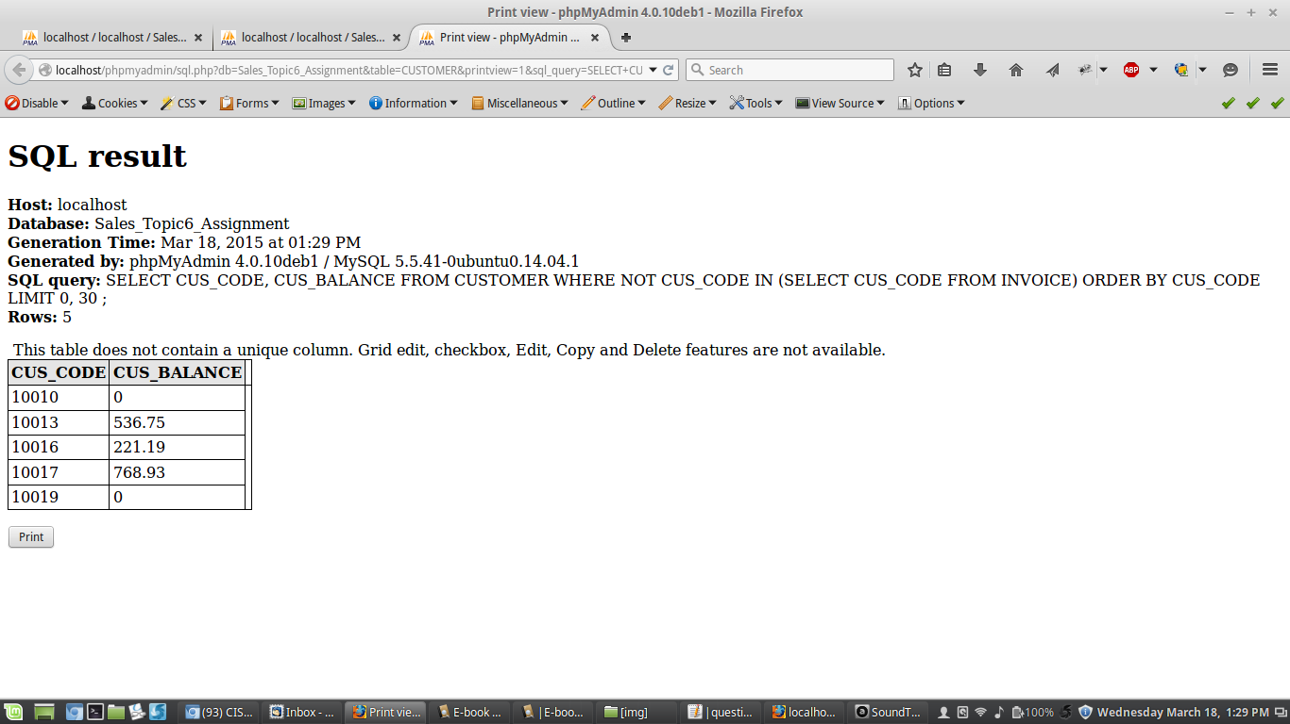

**41. Find the customer balance summary for all customers who have not made purchases during the current invoicing period. The results are shown in Figure P7.41.**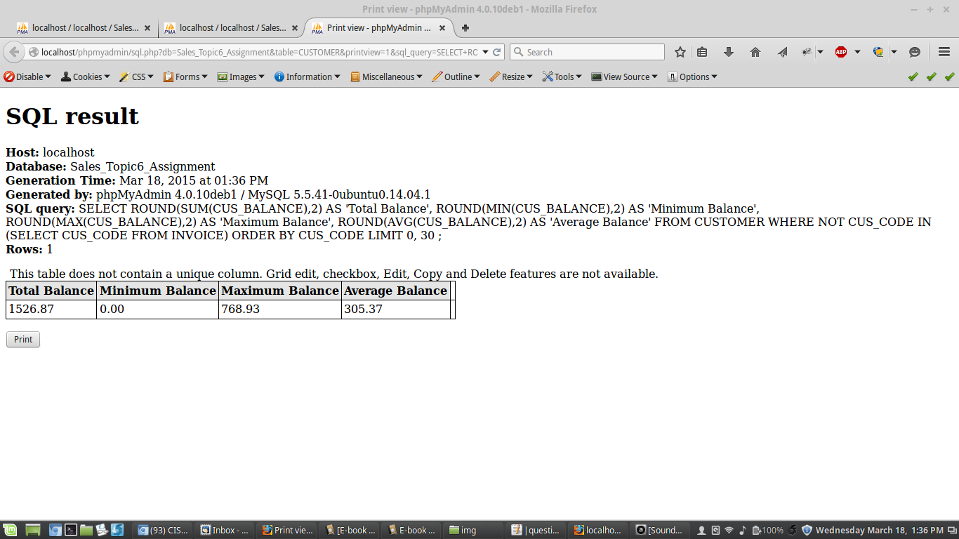

**42. Create a query that summarizes the value of products currently in inventory. Note that the value of each product is a result of multiplying the units currently in inventory by the unit price. Use the ORDER BY clause to match the order shown in Figure P7.42.**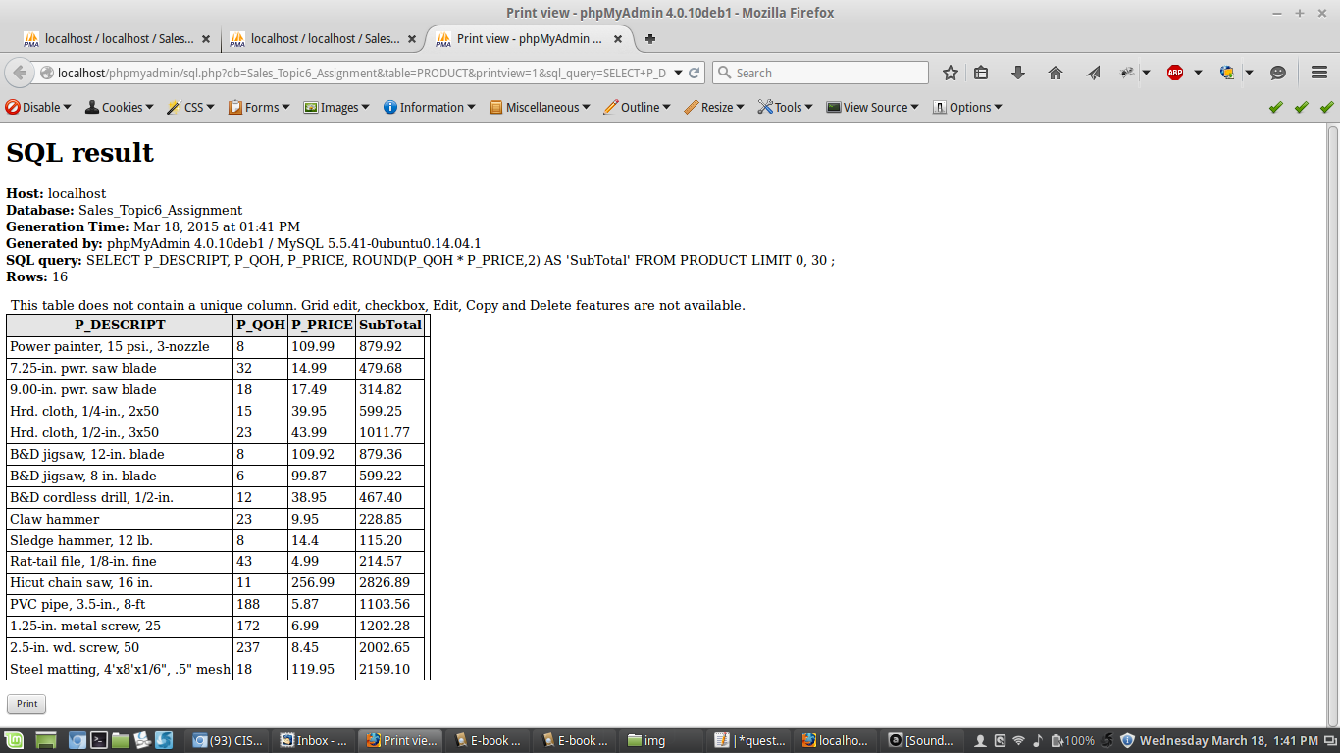

**43. Using the results of the query created in Problem 42, find the total value of the product inventory. The results are shown in Figure P7.43.**